
April 2018

YOUR OUTDOOR PROJECTS START WITH SCREWFIX
This Spring, whatever the weather and whatever the project, start with Screwfix. Celebrate the great outdoors and the new season by stocking up on essential products to get your construction, landscaping, decking and fencing projects completed.
Rhian Bartlett, Trading Director at Screwfix comments: “Our outdoor project range offers our busy tradespeople and DIY enthusiasts with everything they need to complete their outdoor projects this spring. Whenever you’re working outside, we‘ve got all the tools for the job, plus many products you might not expect, from lawn mowers to decking panels and joists.”
With over 570 stores nationwide and our click and collect service that allows you to order goods and collect in as little as one minute, getting the tools and equipment for your outdoor projects has never been easier.

SCREWFIX’S HERO PRODUCTS

P.34 ALUMINIUM WORK PLATFORM, from £21.99
Surely an essential part of kit for outdoor projects. Whether you’re putting up new lighting or decorating, this sturdy platform will help you reach those hard to get to areas.
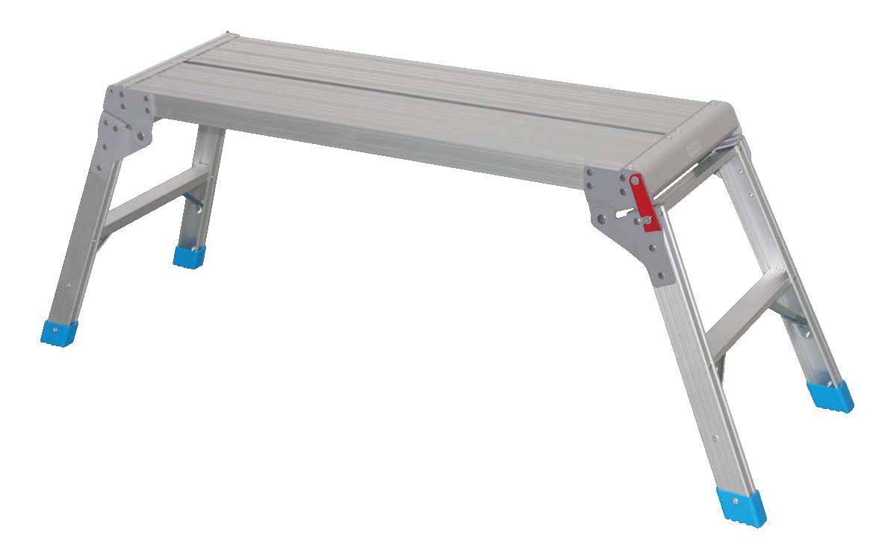

P.7 CONCRETE MIXER £219.99
With a 134 litre drum capacity, this mixer will be a firm fixture on site for concrete projects. Wide wheels make this easy to move and navigate around site.
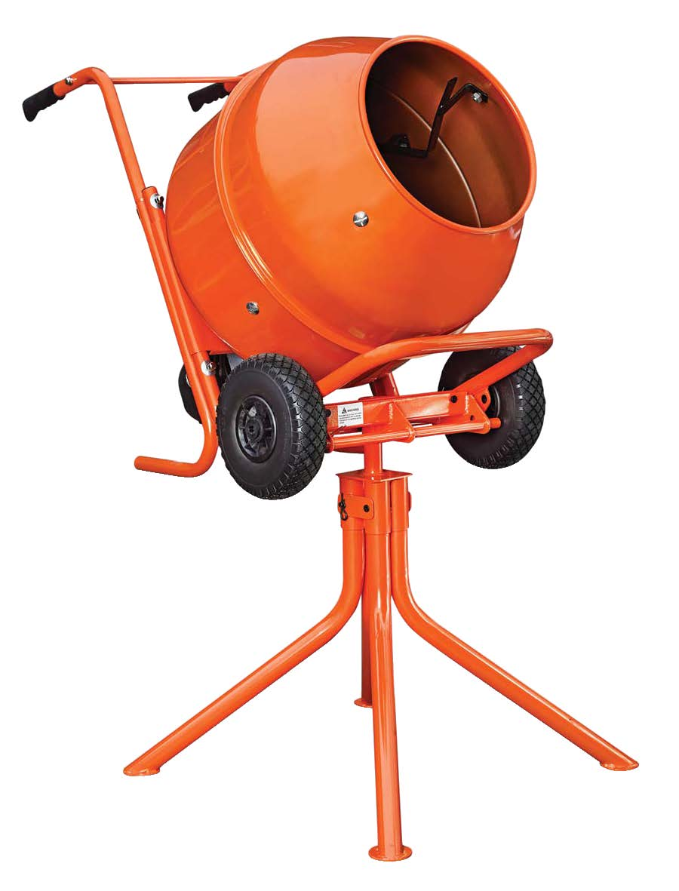

P.9 INSULATED SQUARE HEAD SHOVEL £64.99
Sturdy and robust for outdoor projects, this Spear & Jackson shovel with an insulated handle has been tempered for high performance to see you through the spring season and beyond.
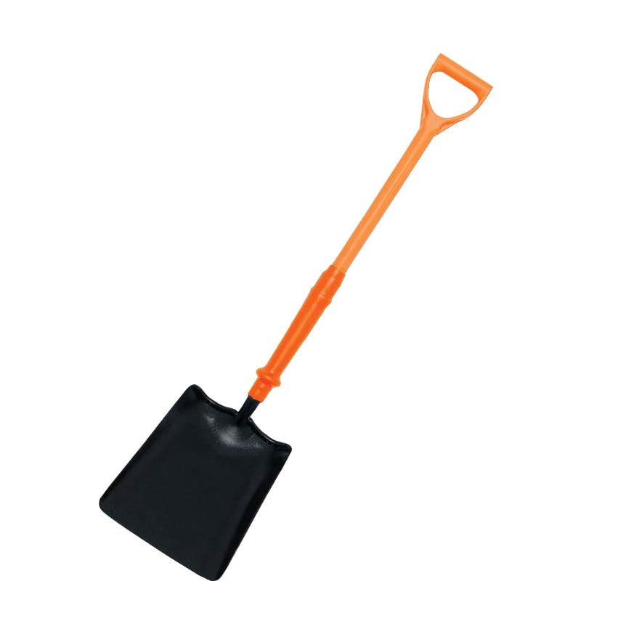
P.22 WOODBURY FENCE PANELS, from £144.99
Ready to smarten any garden area, these decorative Woodbury fence panels are made from pressure treated and planed timber and are built on a rebated frame.
.
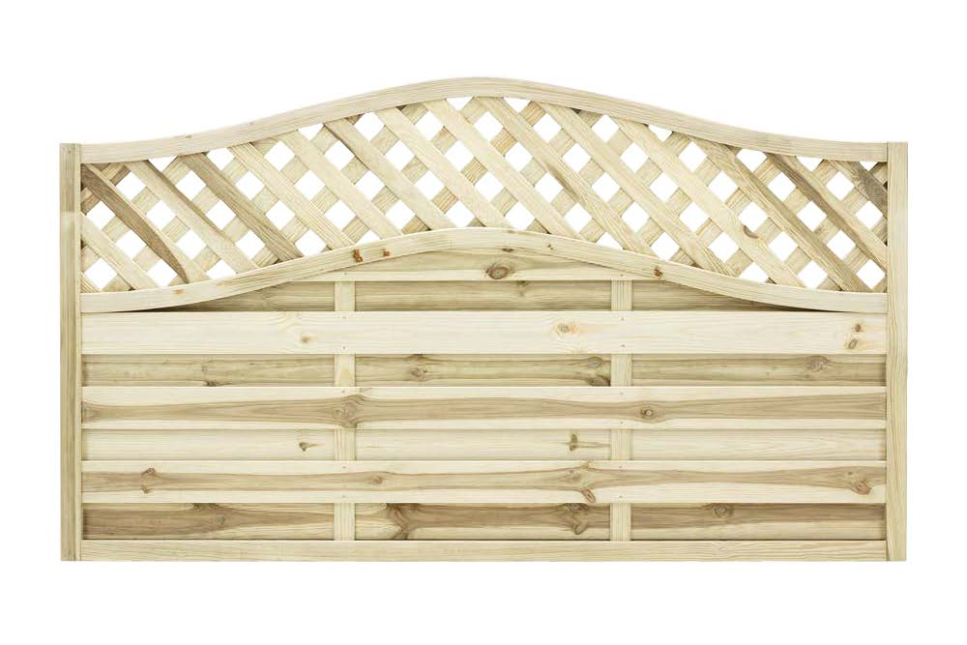
P.52 DEWALT 18V XR CORDLESS BRUSHLESS LINE TRIMMER £199.99
With no cord to contend with, and only a 70 minute charge time, this bump-free line trimmer from DeWalt will have you on the case in no time. The trimmer includes a professional style guard for more cut access and better visibility, as well as a two-speed fully variable trigger which offers total power control and versatility.
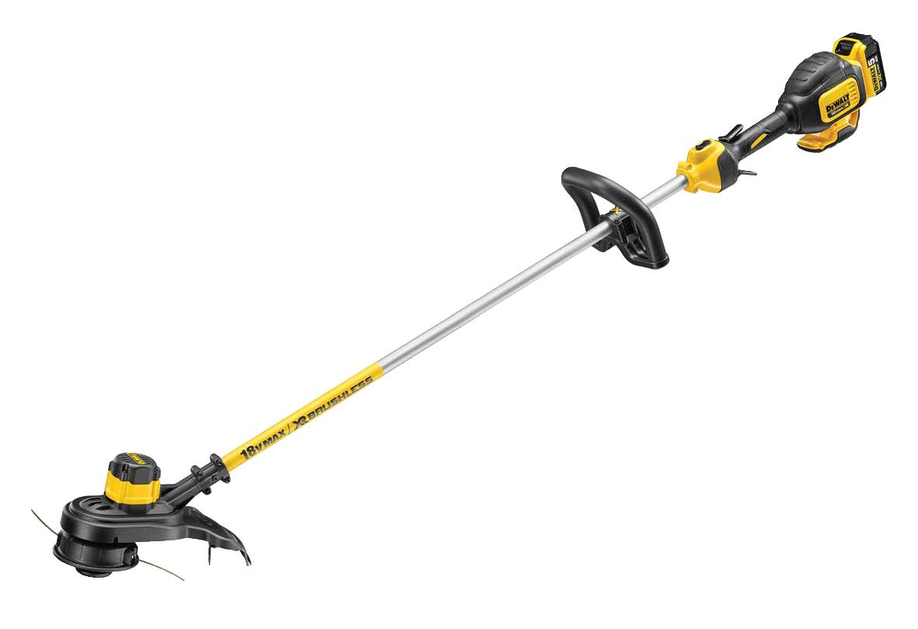

P.49 51CM MOUNTFIELD ROTARY LAWN MOWER £349.99
Recommended by our own Screwfix Market Managers, this robust lawn mower from Mountfield is one of the products in our “best for cutting” range. With five cutting heights and a 60 litre grass collector, the machine makes light work of getting through the mowing.
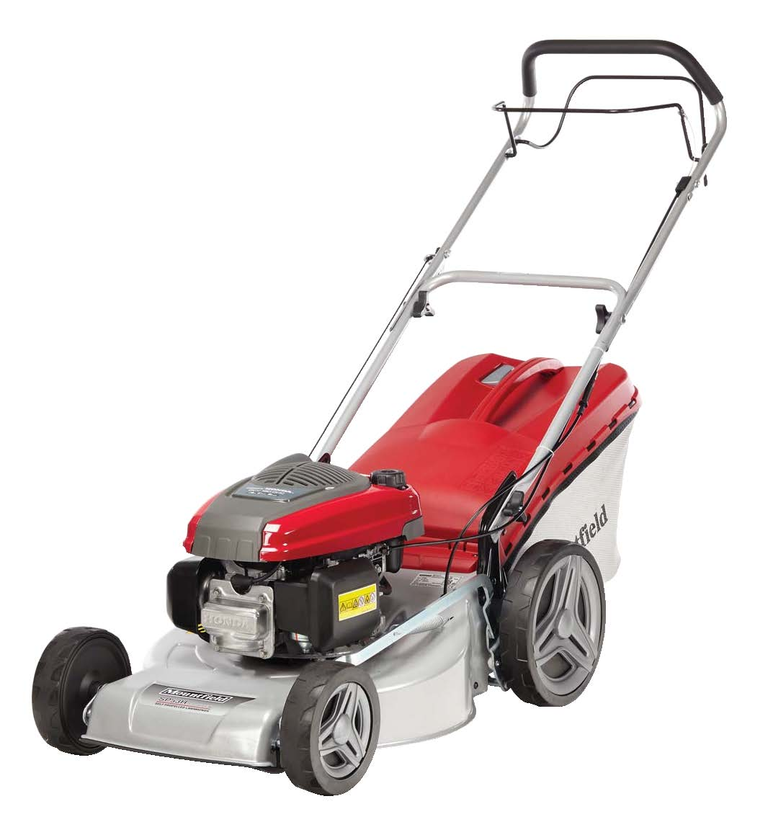
P.67 KARCHER 145 BAR PRESSURE WASHER £279.99
This wheeled Karcher pressure washer has a 3-in-1 multi jet lance that can be adjusted between vario lance, dirt blaster and detergent application and the pressure for each setting is easy to regulate with a simple touch-control trigger.
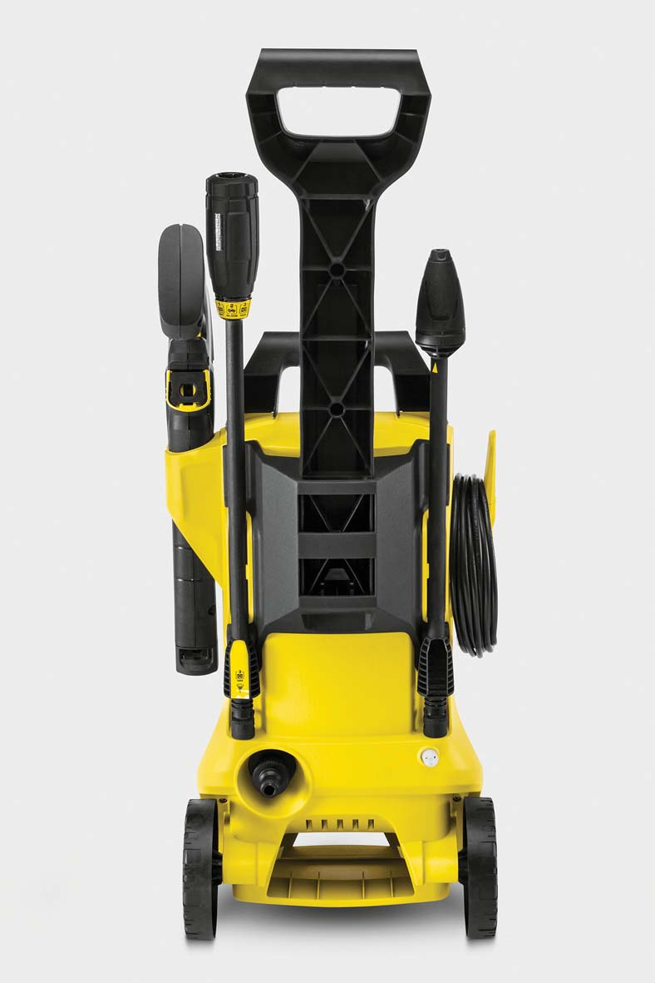

P.6 TITAN 15.5KG BREAKER £149.99
With both a flat and point chisel included, this Titan Breaker can be used on a variety of surfaces for a range of jobs. It’s highly effective and comes with a fan-cooled motor to reduce wear and tear, in turn ensuring it lasts much longer. Priced at £149.99, the tough and durable breaker also has a carry case for added protection.
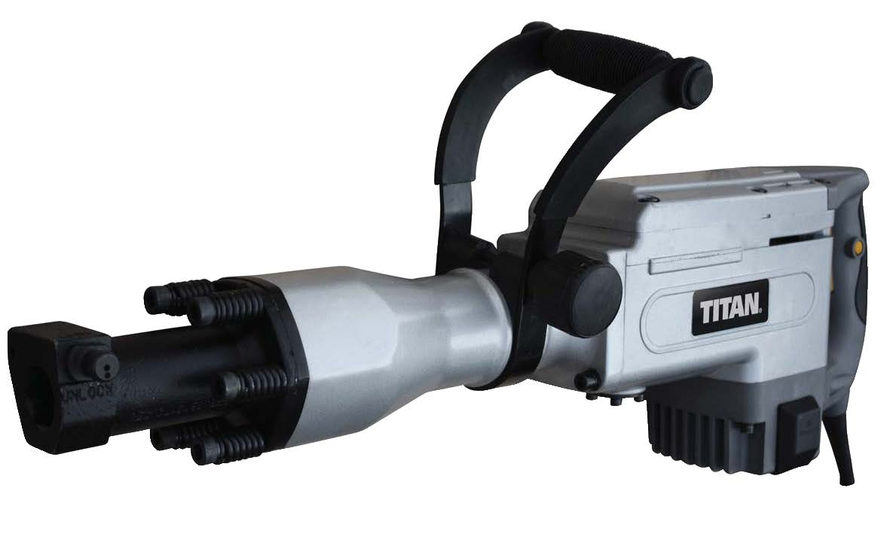

P. 55 60V 40CM CORDLESS CHAINSAW, £214.99
This powerful 60V cordless, brushless, chainsaw from Powerworks provides long run cost efficiency vs petrol models. It has a 40cm bar, tool-less chain tensioner, electronic chain brake and is almost maintenance-free.
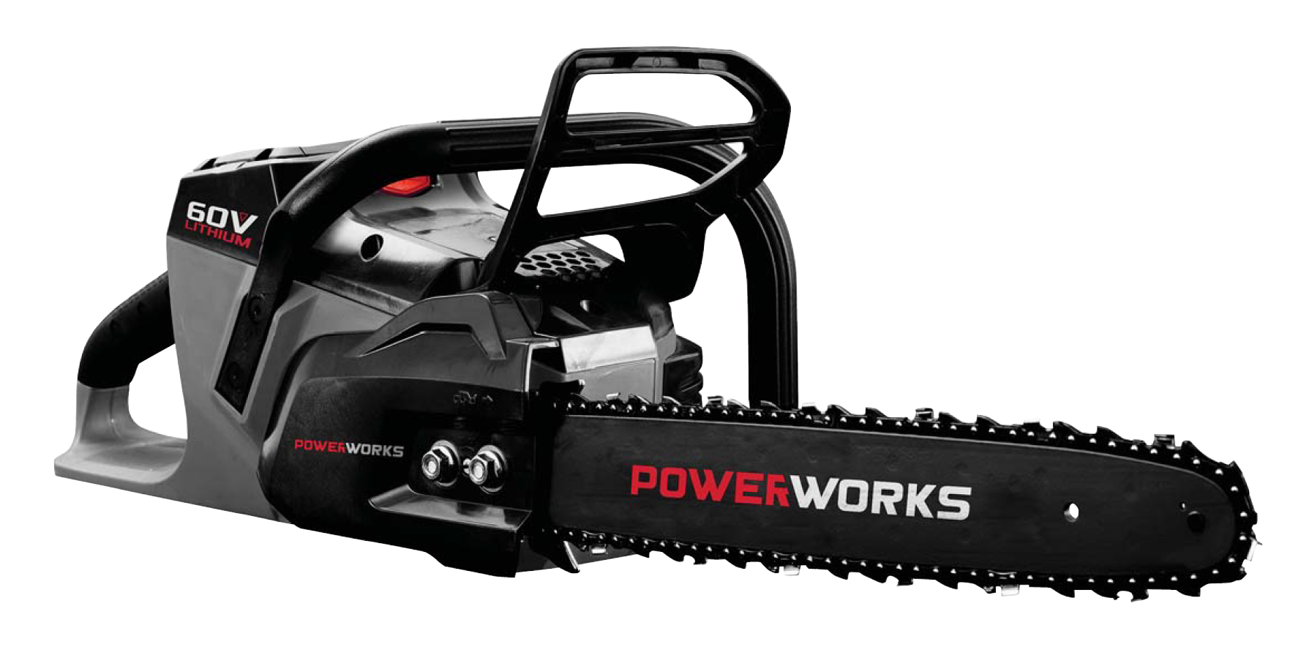

Screwfix stores are open from 7am on weekdays so it’s now easier than ever to get stocked up on the outdoor trade essentials before the start of your working day.
Free copies of the all-new Screwfix Outdoor Projects catalogue are available in store now, or customers can download the Screwfix catalogue app to their Apple or Android smartphone or tablet. Featured products can be ordered via Screwfix.com which hosts hundreds of extended online ranges, or via Screwfix’s mobile site, which allows tradespeople to check stock availability and locate their nearest store.
For more information on Screwfix’s new range of products, visit https://www.screwfix.com/landingpage/outdoor-projects/ or pick up a copy of the new catalogue at a local Screwfix store.
ENDS
Note to editors
About Screwfix:
Screwfix is part of Kingfisher plc, the international home improvement company, with nearly 1,200 stores in 10 countries in Europe, Russia and Turkey. For further information go to www.kingfisher.com.
Screwfix is convenient, straightforward and affordably-priced, helping its trade customers get the job done quickly, affordably and right first time. Tradespeople can shop 30,000 products over the phone, online, via their mobile or in-person from their local store.
- From power tools and work wear to cables and pipe fittings, Screwfix offers over 11,000 products available to pick up from over 570 stores nationwide. Our full range of over 30,000 products can be ordered over the phone, online or from a local store, with orders taken up until 8pm (weekdays) for next day delivery to home or site.
- Screwfix.com attracts 2.6 million unique visitors per week.
- The Screwfix Click & Collect service means customers can conveniently purchase supplies online or over the phone and then collect from the store in as little as one minute.
- Customers can call the UK-based Screwfix Contact Centre 24 hours a day, 7 days a week (including bank holidays) on 03330 112 112.
- UK stores are open 7 days a week, from 7am – 8pm Weekdays, 7am – 6pm Saturdays and 9am – 4pm Sundays. Excludes selected stores. See www.screwfix.com/stores for details.
- London store are open from 6am – 10pm on weekdays
- World leading customer satisfaction levels.
- Screwfix was voted the 5th highest rated UK company for work-life balance by Glassdoor Employees' Choice Awards in 2016.
- Screwfix was awarded Glassdoor’s Best Places to Work in 2017 and 2018.
- Screwfix was awarded Retail Week’s Customer Experience Initiative in 2017.
- In 2016, Screwfix sales surpassed £1bn for the first time.
- Screwfix was awarded 2nd place in Retail Week’s Best Employer Rankings in 2017.
- Screwfix was awarded South West Contact Centre Forum’s Large Contact Centre of the Year Award in 2017.
- For more information about Screwfix please visit our media centre: www.screwfixmedia.co.uk

PRESS information:
For more information, please contact:
Stephanie Jenkins Stephanie.Jenkins@McCann.com / Matthew Allen Matthew.thomas-allen@Mccann.com at McCann Public Relations, Tel: 0121 713 3579

