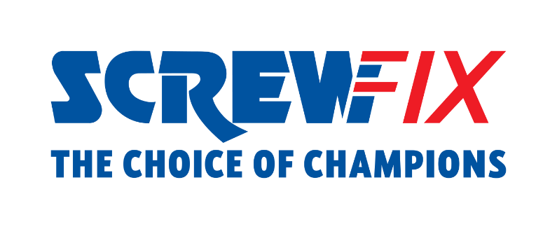

XX July 2022

EREWASH MP MAGGIE THROUP AND SCREWFIX TRADE APPRENTICE WINNER VISIT SCREWFIX STORE IN ILKESTON

Screwfix welcomed Maggie Throup MP, Member of Parliament for Erewash, and Alex Avis, champion of Screwfix Trade Apprentice 2022, to the Ilkeston store in Derbyshire, today [15th July].
Ms Throup and Mr Avis, who is from Nottingham, had the opportunity to take a guided tour of the store and find out from the team how Screwfix succeeds in supporting customers to get their job done affordably and right first time through its hyper-convenient services such as Click and Collect in as little as one minute.
They also met with customers in store and the pair spoke about the importance and benefits of a career in the trade.
Speaking about her visit, Maggie said:
“It was fantastic to meet Alex at Screwfix’s Ilkeston branch and I want to again congratulate him on being named Trade Apprentice 2022.
“Since 2015, over 5,000 people in Erewash have started an apprenticeship, enabling them to learn whilst also working and earning.
“Apprentices like Alex are absolutely essential if we are to build and maintain a skilled workforce for the future and is why the Government is determined to drive up standards through the introduction of schemes such as the Apprenticeship levy and the Lifetime Skills Guarantee, as well as the new T Level qualification beginning in September.
“I want to also thank Screwfix for championing apprentices and recognising their importance to our local economy.”

Alex Avis, Screwfix Trade Apprentice 2022, comments: “Meeting Maggie, and talking about the importance of apprenticeships, was so enlightening and inspiring.
“In winning Screwfix Trade Apprentice, I feel a great responsibility to help be the voice of apprentices and educate people towards a more positive view of a career in the trade.
“In my future, I see myself running my own business, and would be delighted to pass my knowledge onto the next generation of apprentices. I know just how crucial it is for tradespeople and apprentices to work together and take inspiration from one another.”
Every year, the Screwfix Trade Apprentice competition highlights the vital role apprentices play in the industry and provides support to those starting out in their careers with a £10k prize bundle, made up of tools, tech and training.

Internally, Screwfix champions colleagues’ growth too. 850 apprentices are currently training across the business in areas such as Retail Management, Supervisor, HR, Finance, Data and Legal, and Trade Supplier, and over 80% of our apprentices who complete the programmes are promoted.

Staff from Ilkeston store - located in Rutland House, Thurman Street - can participate in the retailer’s apprenticeship scheme, joining 27 colleagues in the area who are attending Trade up to Assistant Store Manager - Aimed at Supervisors who want to progress to an Assistant Store Manager.
The Ilkeston store is part of the company’s growing network of over 800 stores across the UK and Republic of Ireland, with 80 new stores set to open by January 2023.Visit Screwfix’s Ilkeston store, open 7 days a week from 7am from Monday to Saturday.

-ENDS-

About Screwfix:

As a multi-channel trade retailer, customers and colleagues sit at the heart of everything we do. With over 800 stores across the UK and Ireland our aim is to help busy tradespeople get their jobs done quickly, affordably, and right first time.

Screwfix is part of Kingfisher plc, the international home improvement company with more than 1,490 stores, supported by a team of over 80,000 colleagues. Kingfisher operates in eight countries across Europe under retail banners including B&Q, Castorama, Brico Dépôt, Screwfix, TradePoint and Koçtaş. We offer home improvement products and services to consumers and trade professionals who shop in our stores and via our e-commerce channels.
Screwfix is convenient, straightforward, and affordably priced, helping its trade customers shop 34,000 products over the phone, online, via their mobile or in-person from their local store.
- From power tools and work wear to cables and pipe fittings, Screwfix offers over 10,000 products available to pick up from over 775 UK stores nationwide.
- Over 34,000 products can be ordered over the phone, online or from a local store, with orders taken up until 8pm (weekdays) for next day delivery to home or site.*
- Screwfix is committed to minimising its environmental impact to help create a better future for its customers, colleagues, communities, and the planet. Our ambition is to offer sustainable choices and source products that are made to last. At Screwfix, we believe if a job’s worth doing, it’s worth doing well.
- Screwfix.com attracts over 7 million visits per week.
- We have over 11 million active customers a year.
- The Screwfix Click & Collect service enables customers to pick-up their goods in as little as one minute after ordering online or over the phone
- UK-based Screwfix Contact Centre open 24 hours a day, 7 days a week (including bank holidays) on 03330 112 112.
- See www.screwfix.com/stores for store opening information.
- Next day delivery is available within store opening hours.*
- Screwfix Sprint awarded ‘Best Customer Experience’ at the Retail Week Awards 2022. Introduced in 2021, Screwfix Sprint allows customers to place an order on the Screwfix app and get it delivered straight to their location – either at home or on site, in less than an hour.
- RAD 2022, Best Employer Website

