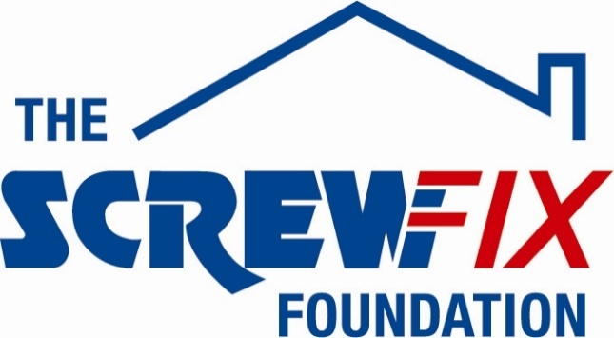

September 2022
Happy Days gets a helping hand from the Screwfix Foundation

- Screwfix Foundation donates £5,000 to Happy Days
- Much-needed funding used for a new Summerhouse
- Set up in 2013, The Screwfix Foundation has raised more than £10m to help local registered charities and not for profit organisations in need across the UK
_________________________________________________________________________

Happy Days, based in Halifax, is celebrating after receiving £5,000 worth of funding from The Screwfix Foundation, the Screwfix charity which supports not for profit organisations in need across the UK to fix, repair, maintain and improve properties and facilities.
At Happy Days, people are committed every day to guaranteeing homeless and vulnerable people receive the support they require, and this includes having spaces tailored to their needs.
Dave Fawcett, founder and CEO of Happy Days, said: “Happy Days supports people who are experiencing homelessness by providing them with the practical and emotional support they need, including accommodation, food and a sense of community.
“The funding from Screwfix will make a real and positive impact on people’s lives and will be used towards a new Summerhouse for one of our communities where our residents can meet, socialise and enjoy time outdoors.”
Claire Flory, The Screwfix Foundation manager says: “The work Happy Days does for people who are vulnerable, giving them hope and a place to rebuild their lives, is inspiring. The much-needed funding will provide a valuable community space for those in need. It’s amazing to see that this donation goes towards such an important project”.
Set up in 2013 after recognising the need to give back, The Screwfix Foundation has raised a staggering £10m for good causes and helped over 2100 local registered charities and not for profit organisations across the UK with refurbishments and building improvements.
Charities and not for profit organisations with relevant projects are invited to apply online for a share of the funding at screwfixfoundation.com.
For more information about The Screwfix Foundation, please visit screwfixfoundation.com.

-ENDS-

About Screwfix:

As a multi-channel trade retailer, customers and colleagues sit at the heart of everything we do. With over 800 stores across the UK and Ireland our aim is to help busy tradespeople get their jobs done quickly, affordably, and right first time.

Screwfix is part of Kingfisher plc, the international home improvement company with more than 1,490 stores, supported by a team of over 80,000 colleagues. Kingfisher operates in eight countries across Europe under retail banners including B&Q, Castorama, Brico Dépôt, Screwfix, TradePoint and Koçtaş. We offer home improvement products and services to consumers and trade professionals who shop in our stores and via our e-commerce channels.
Screwfix is convenient, straightforward, and affordably priced, helping its trade customers shop 34,000 products over the phone, online, via their mobile or in-person from their local store.
- From power tools and work wear to cables and pipe fittings, Screwfix offers over 10,000 products available to pick up from over 775 UK stores nationwide.
- Over 34,000 products can be ordered over the phone, online or from a local store, with orders taken up until 8pm (weekdays) for next day delivery to home or site.*
- Screwfix is committed to minimising its environmental impact to help create a better future for its customers, colleagues, communities, and the planet. Our ambition is to offer sustainable choices and source products that are made to last. At Screwfix, we believe if a job’s worth doing, it’s worth doing well.
- Screwfix.com attracts over 7 million visits per week.
- We have over 11 million active customers a year.
- The Screwfix Click & Collect service enables customers to pick-up their goods in as little as one minute after ordering online or over the phone
- UK-based Screwfix Contact Centre open 24 hours a day, 7 days a week (including bank holidays) on 03330 112 112.
- See www.screwfix.com/stores for store opening information.
- Next day delivery is available within store opening hours.*
- Screwfix Sprint awarded ‘Best Customer Experience’ at the Retail Week Awards 2022. Introduced in 2021, Screwfix Sprint allows customers to place an order on the Screwfix app and get it delivered straight to their location – either at home or on site, in less than an hour.
- RAD 2022, Best Employer Website
- Screwfix won the Pennies Outstanding Achievement award in 2021
- World leading customer satisfaction levels.
- The Wincanton for Screwfix team won the Operational Excellence Award at the Motor Transport Awards 2020.
- For more information, please visit the Screwfix Media Centre: www.screwfixmedia.com

*Please see Screwfix.com for our latest service updates.

PRESS INFORMATION:
For press enquiries, please contact:
screwfix@mccann.com

