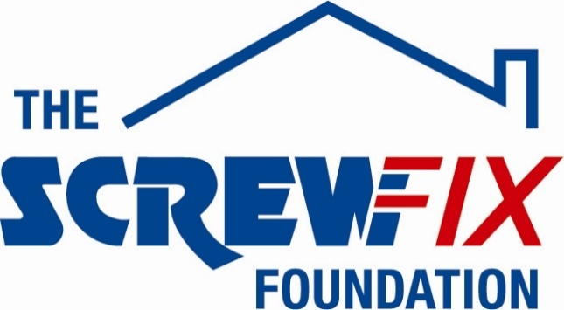

Somerset and Avon Rape & Sexual Abuse Support (SARSAS) gets a helping hand from the Screwfix Foundation

- Screwfix Foundation donates £5,000 to Somerset and Avon Rape & Sexual Abuse Support (SARSAS)
- Much-needed funding used for new counselling rooms
- Set up in 2013, The Screwfix Foundation has raised more than £10m to help local registered charities and not for profit organisations in need across the UK.
_________________________________________________________________________

Somerset and Avon Rape & Sexual Abuse Support (SARSAS), based in Taunton, is celebrating after receiving £5,000 worth of funding from The Screwfix Foundation, the Screwfix charity which supports not for profit organisations in need across the UK to fix, repair, maintain and improve properties and facilities.
SARSAS, are committed every day to ensuring that victim-survivors of rape and sexual abuse receive the support they require, and this includes having friendly and welcoming spaces available.
Claire Bloor, SARSAS CEO, comments: “We are very grateful to The Screwfix Foundation for donating these much-needed funds to support our charity. The funding will be used towards creating new counselling rooms, where people we support can feel safe and comfortable. We’d like to thank everyone who was involved in the fundraising – it’s been a great help to us”.
Claire Flory, The, Screwfix Foundation manager says: “What SARSAS does is crucial for local communities and for victim-survivors of abuse. The much-needed funding will be key in providing a space where clients can come and get the support they need and we are delighted that our donation goes towards such an important project”.
Set up in 2013 after recognising the need to give back, The Screwfix Foundation has raised a staggering £10m for good causes and helped over 2100 local registered charities and not for profit organisations across the UK, with refurbishments and building improvements.
Charities and not for profit organisations with relevant projects are invited to apply online for a share of the funding at screwfixfoundation.com.
For more information about The Screwfix Foundation, please visit screwfixfoundation.com.

-ENDS-

About Screwfix:

As a multi-channel trade retailer, customers and colleagues sit at the heart of everything we do. With over 800 stores across the UK and Ireland our aim is to help busy tradespeople get their jobs done quickly, affordably, and right first time.

Screwfix is part of Kingfisher plc, the international home improvement company with more than 1,490 stores, supported by a team of over 80,000 colleagues. Kingfisher operates in eight countries across Europe under retail banners including B&Q, Castorama, Brico Dépôt, Screwfix, TradePoint and Koçtaş. We offer home improvement products and services to consumers and trade professionals who shop in our stores and via our e-commerce channels.
Screwfix is convenient, straightforward, and affordably priced, helping its trade customers shop 34,000 products over the phone, online, via their mobile or in-person from their local store.
- From power tools and work wear to cables and pipe fittings, Screwfix offers over 10,000 products available to pick up from over 775 UK stores nationwide.
- Over 34,000 products can be ordered over the phone, online or from a local store, with orders taken up until 8pm (weekdays) for next day delivery to home or site.*
- Screwfix is committed to minimising its environmental impact to help create a better future for its customers, colleagues, communities, and the planet. Our ambition is to offer sustainable choices and source products that are made to last. At Screwfix, we believe if a job’s worth doing, it’s worth doing well.
- Screwfix.com attracts over 7 million visits per week.
- We have over 11 million active customers a year.
- The Screwfix Click & Collect service enables customers to pick-up their goods in as little as one minute after ordering online or over the phone
- UK-based Screwfix Contact Centre open 24 hours a day, 7 days a week (including bank holidays) on 03330 112 112.
- See www.screwfix.com/stores for store opening information.
- Next day delivery is available within store opening hours.*
- Screwfix Sprint awarded ‘Best Customer Experience’ at the Retail Week Awards 2022. Introduced in 2021, Screwfix Sprint allows customers to place an order on the Screwfix app and get it delivered straight to their location – either at home or on site, in less than an hour.
- RAD 2022, Best Employer Website
- Screwfix won the Pennies Outstanding Achievement award in 2021
- World leading customer satisfaction levels.
- The Wincanton for Screwfix team won the Operational Excellence Award at the Motor Transport Awards 2020.
- For more information, please visit the Screwfix Media Centre: www.screwfixmedia.com

*Please see Screwfix.com for our latest service updates.

PRESS INFORMATION:
For press enquiries, please contact:
screwfix@mccann.com

