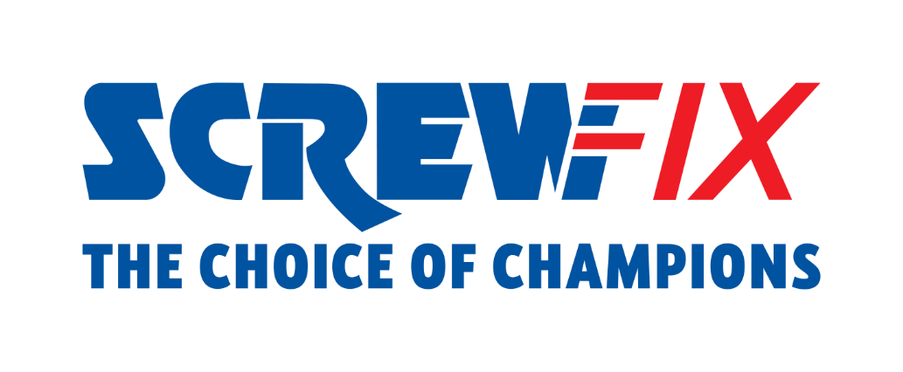

XX September 2022
Welcome back to Screwfix LIVE 2022!

- Doors to Screwfix’s flagship event are now open until Sunday 25th September 2022
- Exclusive deals, talks from leading suppliers, and celebrity appearances throughout the weekend
- Screwfix Live continues online with special deals Monday 26th – Friday 30th September

Screwfix Live 2022, Screwfix’s hugely popular event, has opened its doors and is pleased to welcome customers to Farnborough International Exhibition & Conference Centre until Sunday 25th September 2022.
With more than 170 brands under one roof, the free-to-enter show is the chance for tradespeople, DIY enthusiasts and families to enjoy live product demonstrations, competitions, giveaways and at least 10% off every item purchased.
What’s more, there will be celebrity appearances across the weekend to meet and greet Screwfix customers.
And it doesn’t stop here. To continue to bring the largest trade and DIY show to customers’ fingertips, Screwfix Live will be hosting a virtual event from Monday 26th to Friday 30th September for any customers unable to attend the physical event. Customers can enjoy exclusive deals, special guest appearances, live shows, and great prize draws by visiting Screwfix.com or the Screwfix app.

Max Britten, Managing Director for UK and Republic of Ireland at Screwfix, comments: “We are delighted to officially open the doors to our flagship event, bringing suppliers and customers together, under one roof. With over 170 brands, guest appearances, giveaways, live product demonstrations, and at least 10% off every item purchased at the show, we hope everyone enjoys their time with us this weekend. All customers who cannot attend the physical event, please visit Screwfix.com or the Screwfix app from Monday 26th September, where you can enjoy all that Screwfix Live has to offer, including extraordinary deals and live shows’’.
For regular updates on Screwfix Live, keep an eye on Twitter, Facebook and Instagram or visit screwfix.com .

-ENDS-

About Screwfix:
With over 800 stores across the UK and Ireland, and an extensive product range of over 34,000 products, Screwfix is convenient, straightforward, and affordably priced, help busy tradespeople get their jobs done quickly, affordably, and right first time.
Screwfix is part of Kingfisher plc, the international home improvement company with more than 1,490 stores, supported by a team of over 80,000 colleagues.
From power tools and work wear to cables and pipe fittings, Screwfix offers over 10,000 products available to pick up from over 775 UK stores nationwide.
- Over 34,000 products can be ordered over the phone, online or from a local store, with orders taken up until 8pm (weekdays) for next day delivery to home or site.*
- Screwfix is committed to minimising its environmental impact to help create a better future for its customers, colleagues, communities, and the planet. Our ambition is to offer sustainable choices and source products that are made to last. At Screwfix, we believe if a job’s worth doing, it’s worth doing well.
- Screwfix.com attracts over 7 million visits per week.
- We have over 11 million active customers a year.
- The Screwfix Click & Collect service enables customers to pick-up their goods in as little as one minute after ordering online or over the phone
- UK-based Screwfix Contact Centre open 24 hours a day, 7 days a week (including bank holidays) on 03330 112 112.
- See www.screwfix.com/stores for store opening information.
- Next day delivery is available within store opening hours.*
- Screwfix Sprint awarded ‘Best Customer Experience’ at the Retail Week Awards 2022. Introduced in 2021, Screwfix Sprint allows customers to place an order on the Screwfix app and get it delivered straight to their location – either at home or on site, in less than an hour.
- RAD 2022, Best Employer Website
- For more information, please visit the Screwfix Media Centre: www.screwfixmedia.com

*Please see Screwfix.com for our latest service updates.

PRESS INFORMATION:
For press enquiries, please contact:
screwfix@mccann.com

