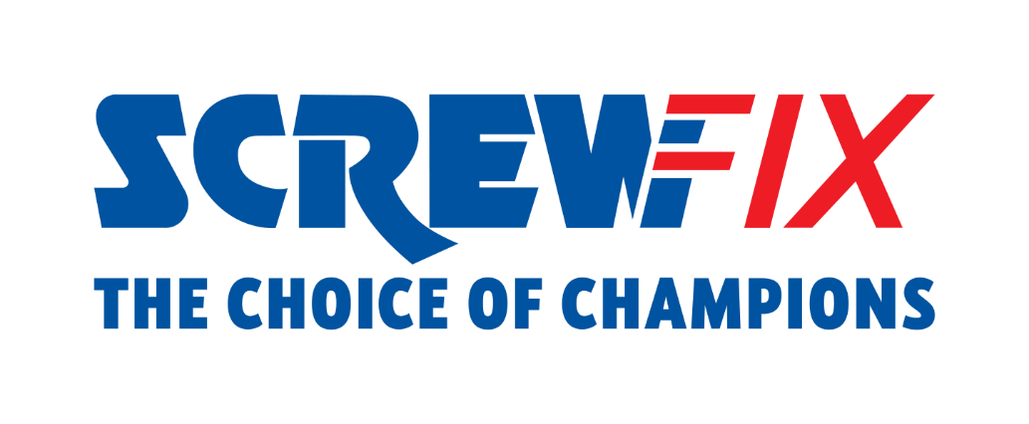

XX September 2022
Screwfix LIVE 2022 ready to welcome customers back to Farnborough!

- The Highly anticipated Screwfix’s flagship event returns to Farnborough 23rd - 25th September 2022
- Celebrity appearances across the weekend
- 10 finalists from the UK and Ireland will compete to be crowned Screwfix Top Tradesperson 2022
- 10% off for any product purchased at the event

Screwfix is delighted to welcome customers back to Screwfix Live 2022, with the hugely popular event ready to open its doors in less than 2 days.
The free-to-enter show is returning to Farnborough International Exhibition & Conference Centre from Friday 23rd September – Sunday 25th September 2022 with all the best brands, to give tradespeople and DIY enthusiasts the chance to get their hands on the best products on the market.

A free £20 value goody bag will be ready to collect at the venue for all customers who pre-register. So, if you haven’t already, NOW is the time to register online at www.screwfixlive.com.
With more than 170 brands under one roof, customers and families will be able to enjoy live product demonstrations, competitions, and giveaways. What’s more, there will be celebrity appearances across the weekend to meet and greet Screwfix customers.

It doesn’t stop here. Screwfix Live will host the Screwfix Top Tradesperson final. Screwfix's prestigious annual competition will crown the new champion of the trade, with 10 skilled finalists from the UK and Republic of Ireland competing for the title.
Max Britten, Managing Director for UK and Republic of Ireland at Screwfix, comments: “It's amazing to be back in Farnborough and we can’t wait to welcome customers and suppliers back to our flagship event. With over 170 brands under the same roof, the final of Screwfix Top Tradesperson 2022 and at least 10% off every item purchased at the show, we look forward to opening our doors on Friday 23rd September and welcoming visitors to Screwfix Live 2022.
To register their attendance or for regular updates on the event follow visitors should visit Screwfix Live, or follow us on Twitter, Facebook and Instagram .

-ENDS-

About Screwfix:

With over 800 stores across the UK and Ireland, and an extensive product range of over 34,000 products, Screwfix is convenient, straightforward, and affordably priced, help busy tradespeople get their jobs done quickly, affordably, and right first time.
Screwfix is part of Kingfisher plc, the international home improvement company with more than 1,490 stores, supported by a team of over 80,000 colleagues.
From power tools and work wear to cables and pipe fittings, Screwfix offers over 10,000 products available to pick up from over 775 UK stores nationwide.
- Over 34,000 products can be ordered over the phone, online or from a local store, with orders taken up until 8pm (weekdays) for next day delivery to home or site.*
- Screwfix is committed to minimising its environmental impact to help create a better future for its customers, colleagues, communities, and the planet. Our ambition is to offer sustainable choices and source products that are made to last. At Screwfix, we believe if a job’s worth doing, it’s worth doing well.
- Screwfix.com attracts over 7 million visits per week.
- We have over 11 million active customers a year.
- The Screwfix Click & Collect service enables customers to pick-up their goods in as little as one minute after ordering online or over the phone
- UK-based Screwfix Contact Centre open 24 hours a day, 7 days a week (including bank holidays) on 03330 112 112.
- See www.screwfix.com/stores for store opening information.
- Next day delivery is available within store opening hours.*
- Screwfix Sprint awarded ‘Best Customer Experience’ at the Retail Week Awards 2022. Introduced in 2021, Screwfix Sprint allows customers to place an order on the Screwfix app and get it delivered straight to their location – either at home or on site, in less than an hour.
- RAD 2022, Best Employer Website
- For more information, please visit the Screwfix Media Centre: www.screwfixmedia.com

*Please see Screwfix.com for our latest service updates.

PRESS INFORMATION:
For press enquiries, please contact:
screwfix@mccann.com

