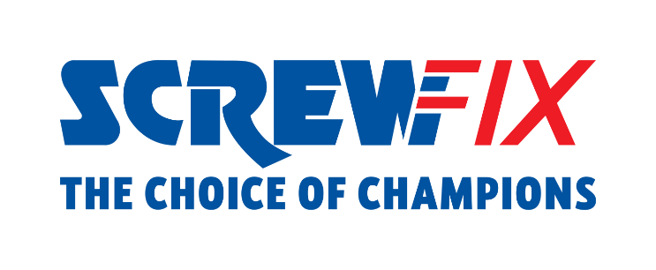

25 October 2022

**Screwfix and the Woodland Trust partner to support Snaizeholme project in North Yorkshire**

Screwfix is delighted to announce the launch of its partnership with the Woodland Trust, the largest woodland conservation charity in the UK.

Supported by funding from Screwfix, the Woodland Trust will restore, protect, and plant a new native forest at the charity’s Snaizeholme project in North Yorkshire.

With a £50,000 donation, Screwfix will support the regeneration and rewilding of the Yorkshire Dales National Park area, with the aim to improve biodiversity and create a flourishing haven for woodland animals, including red squirrels and birds.

Snaizeholme is part of the Woodland Trust’s ambitious plan to establish England’s largest new native woodland and is set to become the flagship project for the charity, which is celebrating its 50th birthday this year.

Pip Greensmith, Head of Partnerships for the Woodland Trust, says: *“The Woodland Trust’s vision for Snaizeholme will restore an entire ecosystem, lock up carbon for years to come, and help mitigate flooding in the catchment. We have an opportunity to boost biodiversity at a time when the natural world is in crisis. Woodland creation on this scale is imperative if we are to tackle the potentially catastrophic loss of nature. Transforming the landscape with sympathetic native planting, and allowing natural regeneration to occur, forms a critical part of the work of the Woodland Trust. Support from businesses like Screwfix allows this to become a reality.”*

In the next 12 months, with Screwfix’s contribution, 4,000 trees will be planted in Snaizeholme, home to 250 acres of upland peat bog, which the Woodland Trust is looking to restore in the area to preserve its role as mosaic of natural habitats for protected species as well as its CO2-absorbing properties, vital for the environment.

Olivia Green, Sustainability Manager at Screwfix, comments: *“As a business, we are thrilled to partner with the Woodland Trust. Screwfix and the Woodland Trust share the same vision of a greener and more sustainable future. The project at Snaizeholme will help boost the water quality of the streams running down into Snaizeholme Beck and safeguard native residents.*

*“At Screwfix, we know it is vital to restore damaged habitats as well as reduce the environmental impacts we have as a business.* *As part of Kingfisher, Screwfix's contribution to the Snaizeholme project also supports the Group’s long-term commitment to protecting nature and becoming Forest Positive by 2025, by creating more forests than we use.* *We look forward to seeing this amazing habitat thrive.”*

To discover more about Screwfix’s partnership with the Woodland Trust, follow Screwfix on Facebook, Instagram, and Twitter.

**ENDS**

**About Screwfix:**

With over 800 stores across the UK and Ireland, and an extensive product range of over 38,000 products, Screwfix is convenient, straightforward, and affordably priced, help busy tradespeople get their jobs done quickly, affordably, and right first time.

Screwfix is part of Kingfisher plc, the international home improvement company with more than 1,490 stores, supported by a team of over 80,000 colleagues.

From power tools and work wear to cables and pipe fittings, Screwfix offers over 10,000 products available to pick up from over 775 UK stores nationwide.

* Over 38,000 products can be ordered over the phone, online or from a local store, with orders taken up until 8pm (weekdays) for next day delivery to home or site.*
* Unbeatable value at Screwfix is prices, quality and convenience you can trust. Over 1,000 prices cuts, hundreds of prices locked until the end of the year, and more than 8,000 bulk save items, helping tradespeople to get what they need, when they need it. Screwfix is committed to meeting the need of its customers.
* Screwfix is committed to minimising its environmental impact to help create a better future for its customers, colleagues, communities, and the planet. Our ambition is to offer sustainable choices and source products that are made to last. At Screwfix, we believe if a job’s worth doing, it’s worth doing well.
* Screwfix.com attracts over 7 million visits per week.
* We have over 11 million active customers a year.
* The Screwfix Click & Collect service enables customers to pick-up their goods in as little as one minute after ordering online or over the phone
* UK-based Screwfix Contact Centre open 24 hours a day, 7 days a week (including bank holidays) on 03330 112 112.
* See [www.screwfix.com/stores](http://www.screwfix.com/stores) for store opening information.
* Next day delivery is available within store opening hours.*
* Screwfix Sprint awarded ‘Best Customer Experience’ at the Retail Week Awards 2022. Introduced in 2021, Screwfix Sprint allows customers to place an order on the Screwfix app and get it delivered straight to their location – either at home or on site, in less than an hour.
* RAD 2022, Best Employer Website
* For more information, please visit the Screwfix Media Centre: [www.screwfixmedia.com](http://www.screwfixmedia.com)

*Please see Screwfix.com for our latest service updates.

**PRESS INFORMATION:**

For press enquiries, please contact:

[screwfix@mccann.com](mailto:screwfix@mccann.com)