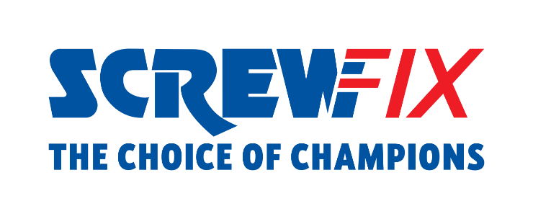

January 2023
Screwfix customer from Leamington Spa wins a brand-new electric van by purchasing on the app

- Rebecca from Leamington Spa has won an electric Ford transit van by participating in the Screwfix Big App Giveaway
- Screwfix launched the competition last October, receiving over 430,000 entries
- The van will be of massive help for the winner, as she currently packs all her tools in her car

Rebecca, a greenkeeper from Leamington Spa, is the winner of the Screwfix Big App Giveaway, driving home with a brand-new electric van that she will make the most of for her business.
In October 2022, Screwfix gave customers the chance to win fantastic prizes by purchasing via app, including Smart Home heating bundles, Iphone14, and TUI Holiday e-vouchers, with the first prize being an all-electric Ford Transit van.
Based in Leamington Spa, Rebecca has been a Screwfix customer for years. She has been in the trade for 12 years as a full-time greenkeeper at Fulford Heath Golf Club and spends most of her weekends working on landscaping projects.
The new electric transit van will be massively beneficial for her business, allowing Rebecca to have more space for her tools and travel sustainably.
She says: “I can’t believe it; I am literally over the moon. When I placed the orders on the app, I could only hope to win one of the prizes, I certainly couldn't imagine winning the main prize! I currently pack all my equipment in my car so winning a brand-new electric van will make transporting my tools so much easier and help me expand my business too.”
On the 11th of January, Rebecca received her new vehicle at home and celebrated the winning in her trusted Screwfix store in Leamington Spa, Unit 4 Tachbrook Link, Tachbrook Park Drive, CV34 6RS.
Jack Wallace, Marketing Director at Screwfix, said: “We are delighted to give Rebecca the keys to her new electric van. At Screwfix, we pride ourselves on championing the trade and the Big App Giveaway proves it. The winning prize was incredibly sought after with more than 160,000 customers entering the competition in less than a month. It’s a real bonus that the van is going to someone where it will make a real difference in helping them to grow their business.”
To access all the app-exclusive offers, customers should download the Screwfix App. Alternatively, they can shop online on Screwfix website, or visit one of Screwfix 800+ stores across the UK and Ireland.

About Screwfix:
With over 800 stores across the UK and Ireland, and an extensive product range of over 38,000 products, Screwfix is convenient, straightforward, and affordably priced, help busy tradespeople get their jobs done quickly, affordably, and right first time.
Screwfix is part of Kingfisher plc, the international home improvement company with more than 1,490 stores, supported by a team of over 80,000 colleagues.
From power tools and work wear to cables and pipe fittings, Screwfix offers over 10,000 products available to pick up from over 775 UK stores nationwide.
- Over 38,000 products can be ordered over the phone, online or from a local store, with orders taken up until 8pm (weekdays) for next day delivery to home or site.*
- Unbeatable value at Screwfix is prices, quality, and convenience you can trust. Over 1,000 prices cuts, hundreds of prices locked until the end of the year, and more than 8,000 bulk save items, helping tradespeople to get what they need, when they need it. Screwfix is committed to meeting the need of its customers.
- Screwfix is committed to minimising its environmental impact to help create a better future for its customers, colleagues, communities, and the planet. Our ambition is to offer sustainable choices and source products that are made to last. At Screwfix, we believe if a job’s worth doing, it’s worth doing well.
- Screwfix.com attracts over 7 million visits per week.
- We have over 11 million active customers a year.
- The Screwfix Click & Collect service enables customers to pick-up their goods in as little as one minute after ordering online or over the phone
- UK-based Screwfix Contact Centre open 24 hours a day, 7 days a week (including bank holidays) on 03330 112 112.
- See www.screwfix.com/stores for store opening information.
- Next day delivery is available within store opening hours.*
- Screwfix Sprint awarded ‘Best Customer Experience’ at the Retail Week Awards 2022. Introduced in 2021, Screwfix Sprint allows customers to place an order on the Screwfix app and get it delivered straight to their location – either at home or on site, in less than an hour.
- RAD 2022, Best Employer Website
- Screwfix recognised at the BRC’s Climate Action Roadmap Showcase 2022 for “Driving towards net zero properties”.
- For more information, please visit the Screwfix Media Centre: www.screwfixmedia.com

*Please see Screwfix.com for our latest service updates.

PRESS INFORMATION:
For press enquiries, please contact:
screwfix@mccann.com

